LECTURES AND CONFERENCES

UST Science webinar emphasizes One Health approach

The Science, Technology, and Society (STS) Unit of the Department of Biological Sciences of the UST College of Science hosted the second STS Summit with the theme “Understanding One Health for a Sustainable Future.” It was held via Zoom on November 12, 2021.
This year, the Summit highlighted the One Health approach, which recognizes the interconnectedness of people’s health to the health of animals and their shared environment. The One Health idea has been pertinent over the last few years as a myriad of factors continually affect change in the interactions between humans, animals, and the environment.
Four esteemed speakers shared their expertise in using science-based approaches for their studies related to the One Health agenda. For environmental health, E-Kwento PH Director Mr. Ronaldo Magsakay delivered a lecture on effectively communicating environmental awareness using digital arts and social media as a platform.
Dr. Emiel de Lange, a post-doctoral research consultant at the University of Edinburgh, tackled animal health by applying social science research on Cambodian social groups to understand wildlife poisoning in their communities.
Furthermore, human health was presented by Dr. Benedict Maralit, the Director of the Philippine Genome Center Core Sequencing Facility, and Dr. Pia Marie Albano, a researcher and faculty member of
the UST Biological Sciences Department.
Maralit delivered a talk about the usage of sequencing technologies at the plight of COVID-19 in the Philippines, while Albano shared her experiences and challenges in conducting a clinical validation study of a COVID-19 kit in the country.
Science, Technology, and Society (STS) is offered as a course under the General Education curriculum of UST. It inculcates science appreciation among students and is anchored on the teachings of Pope Francis within the encyclical Laudato Si’.
The annual STS Summit was established by the Department of Biological Sciences’ to create an avenue of active discussion. More so, it fosters the advocacy of effective information dissemination in the usage of science and technology as an effective tool to address many social dilemmas to the public.
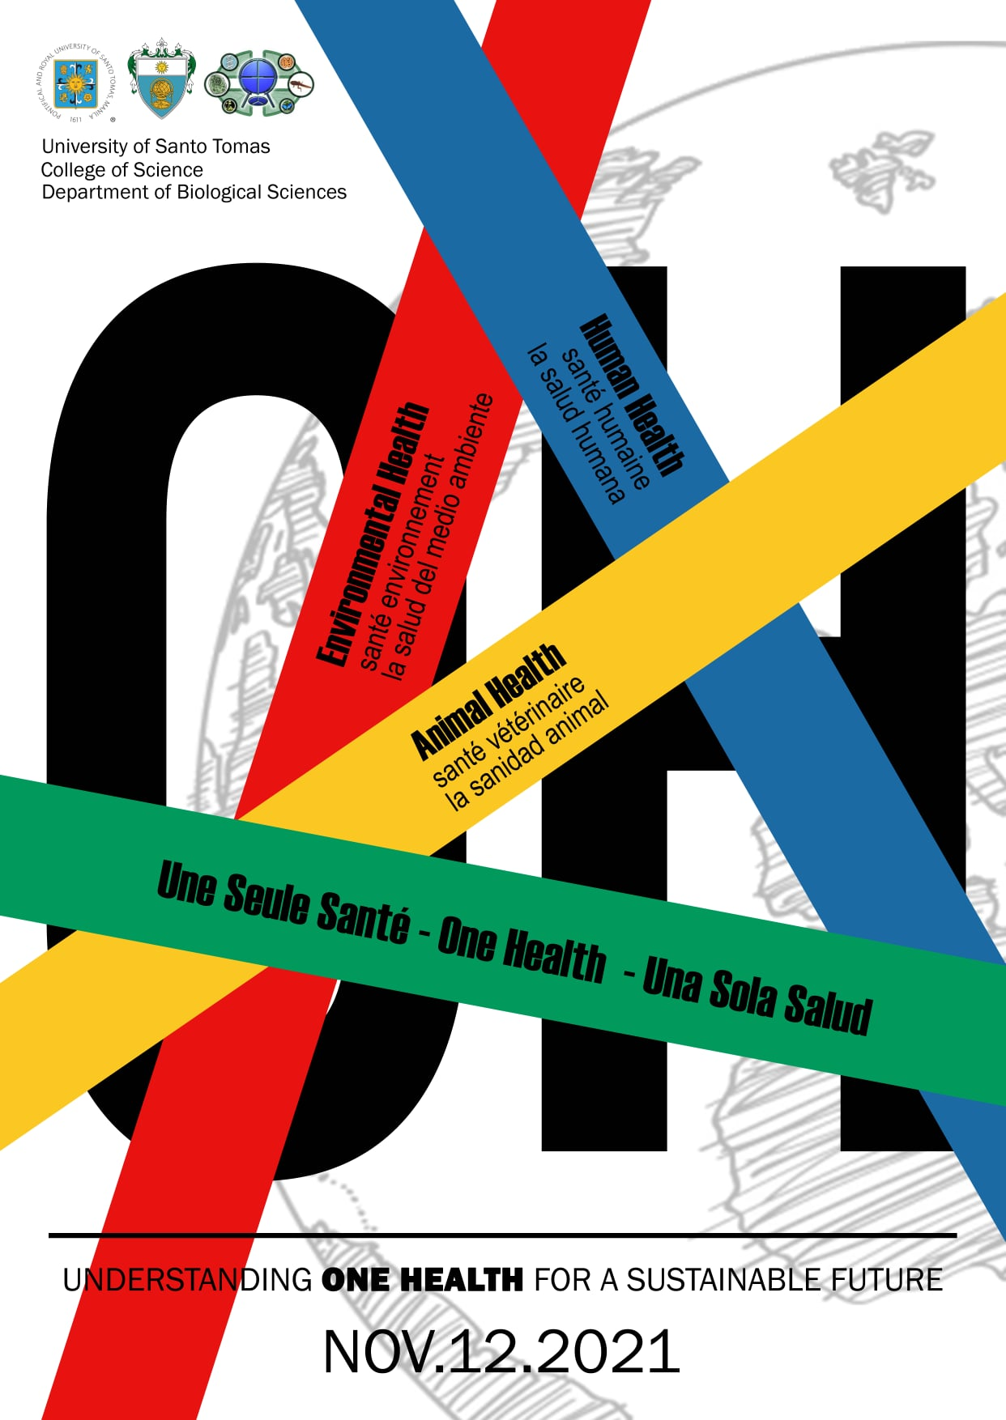
Event poster

