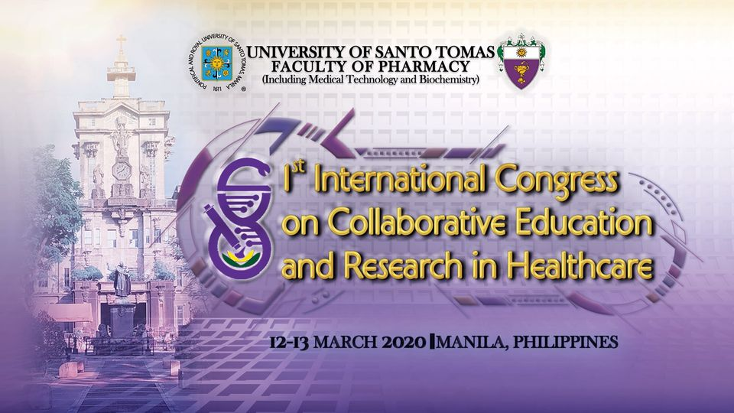
Day 1: 09 March 2021
09:00 – 09:30 | Registration
 | Opening Ceremonies
 | Invocation and National Anthem
 | Welcome Remarks
 | Opening Remarks and Overview of the Program
09:30 – 10:30 | Keynote Speaker
10:30 – 11:30 | Opening of Poster Exhibit
11:30 – 01:00 | Poster and sponsor presentation
1:30 on wards | Don Mariano Que Memorial Lecture
Day 2: 10 March 2021
8:30 – 09:00 | Registration
09:00 – 10:00 | Plenary 1
10:00 – 11:00 | Plenary 2
11:00 – 11:30 | Parallel Speaker 1
11:30 – 12:00 | Parallel Speaker 2
12:00 – 01:00 | Lunch Break: Poster and Sponsor Presentation
01:00 – 01:30 | Parallel Speaker 3
01:30 – 02:00 | Parallel Speaker 4
02:00 – 03:00 | Oral Presentation
03:00 – 04:00 | Major Sponsor Video Presentation
Day 3: 11 March 2021
8:30 – 09:00 | Registration
09:00 – 10:00 | Plenary 3
10:00 – 11:00 | Plenary 4
11:00 – 11:30 | Parallel Speaker 5
11:30 – 12:00 | Parallel Speaker 6
12:00 – 01:00 | Lunch Break: Poster and Sponsor Presentation
01:00 – 01:30 | Parallel Speaker 7
01:30 – 02:00 | Parallel Speaker 8
02:00 – 03:00 | Oral Presentation
03:00 – 04:00 | Major Sponsor Video Presentation
Day 4: 12 March 2021
8:30 – 09:00 | Registration
09:00 – 10:00 | Plenary 5
10:00 – 11:00 | Plenary 6
11:00 – 12:00 | Plenary 7
12:00 – 01:00 | Lunch Break: Poster and Sponsor Presentation
01:00 – 01:30 | Parallel Speaker 9
01:30 – 02:00 | Parallel Speaker 10
02:00 – 03:00 | Oral Presentation
03:00 – 04:00 | Awarding Ceremonies
04:00 – 04:30 | Closing Ceremonies

